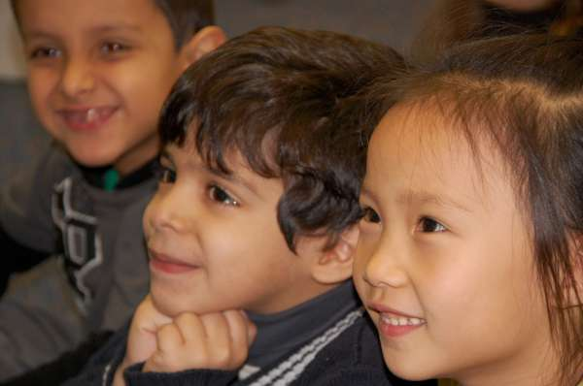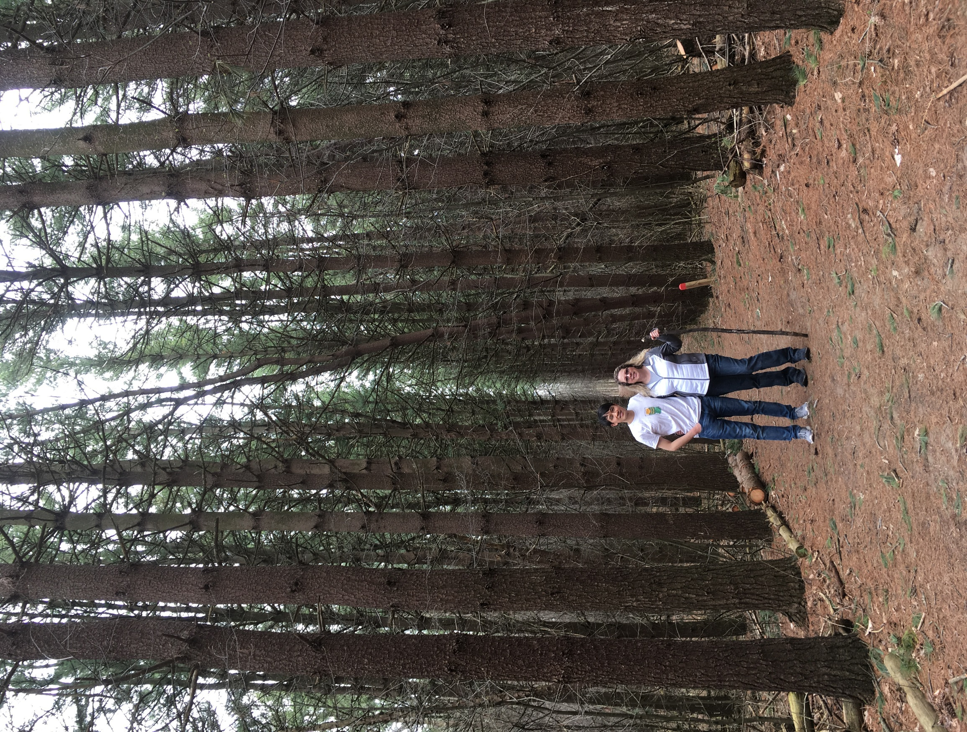

Share a meal, take a walk, have coffee, enjoy holidays (trick or treating, Thanksgiving, Chinese New Year, Ramadan, Holi, etc.). This program is a great opportunity to learn about cultures from around the world, expand your horizons, and make new friends.

Make a big difference in the lives of International Glencairn Elementary families by joining the Glencairn friendship family program. American and international families can meet several times per semester, depending on the familys' schedules.

**Join the GLENCAIRN FRIENDSHIP**

**FAMILY PROGRAM**

Mrs. Bungard and her international friend. He has been part of her friendship family for 3 years.

ABOUT US

WHY JOIN?

* To learn about the world.
* To develop friendships that can turn into lifelong friendships.
* To enhances your understanding of other cultures.

OUR GOALS

* To allow international families to develop American friendships
* To help international families experience the "American way of life" within homes, families, and the community
* To provide opportunities for families to sharing their culture and traditions

CONTACT INFORMATION

Julie Bungard

ELL Teacher/District Coordinator

[Julie.bungard@elps.us](mailto:Julie.bungard@elps.us)

517-333-7484

Ask for an application

* PROJECT MANAGEMENT  
  Nulla facilisi. Lorem ipsum dolorsit amet, conse ctetuer laoreet dolor.

**www.glencairnells.weebly.com**

**FRIENDSHIP FAMILY PROGRAM**