Questions to Ask During
Parent/Teacher Conferences

- What skills and knowledge will my child be expected to master this year? What are the standards, and how will we know if my child is meeting them?

- How will my child be evaluated? What information is used? How are grades determined, and what grading system do you use? (Ask to have the grading system explained if necessary.)

- What can I do at home to help be involved? Do you have a system for parents to know what homework is assigned?

- What do you see as my child's strengths/weaknesses?

- How is my child doing socially? Do they seem to have friends and get along with the other students? Does my child seem happy overall?

- Does my child behave respectfully to you? Do they follow class rules? Are they polite and kind?

- Does my child work up to their potential? Are they doing their best?

- Does my child turn in assignments on time, and stay on task for the most part?

- Does my child speak up or ask questions during class? Do they ask for help if they are confused or unsure?

- What's our action plan for this coming term? What goals should we set for work at school, along with homework?

- Does my child see the board okay?

- Is my child organized?
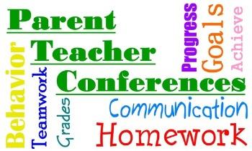
- Does my child daydream?

- What more can I do to help?

