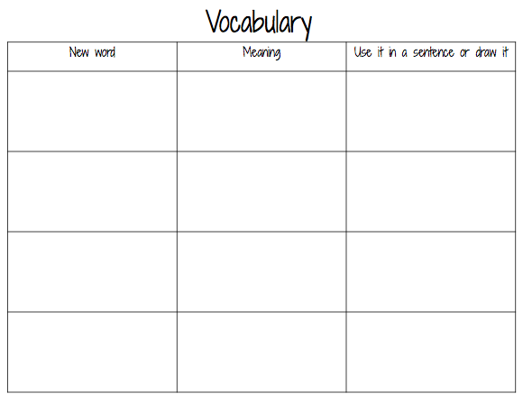
Name_____________________________________________ Date__________________________________________

